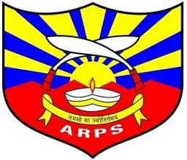
ASSAM RIFLES PUBLIC SCHOOL, MANTRIPUKHRI

Assam Rifles Public School, Mantripukhri will be hosting a State Level Inter School Debate Competition on 25th November 2022 for two categories i.e. Junior (Classes VI to VIII) and Senior (Classes IX to XII) for the academic session 2022-23. The topics for the said competition are as follows:
Junior Category (Classes VI to VIII)
- Underage should not be allowed to use social media.
- Money can't buy happiness.
- Are online classes good or bad for the students?
Senior Category (Classes IX to XII)
- Social media has improved human communication.
- Is technology raising unemployment rates?
- Should coaching classes be encouraged for the students.
- Should Healthcare and Education be free for everyone?
Instructions:
- There should be two participants (one for and another against) for each category (both Senior & Junior). Therefore, a total of four participants must represent a school for the mentioned competition.
- A single topic should be chosen by the representatives through lucky draw for each category.
- Two participants (one for and another against) would be called out from each participating schools.
- Each participant shall be given a maximum of 3 minutes to present his/her speech regarding the topic.
- After the completion of the speech, the two participants shall be given additional 4 minutes time for argumentation/debate.
- The provided instructions will remain same for both the categories.
Interested schools can nominate 2 participants each for Junior & Senior category. The nominal roll no. of the participants shall be submitted to ARPS, Mantripukhri on or before 20th November 2022 furnished with the following documents:
- Aadhar card of the student.
- Identity card issued by the school.
NB: 1) Only 8 schools will be considered based on first come first served basis.
2) Medium of argumentations/debates will be English only

